Tips for Setting Yourself Up to Appear Online
- Think about where to sit with your laptop/camera device and what will be viewable behind or around you. Avoid sitting in front of a lot of distracting objects.

- Avoid wearing a really busy plaid or patterned outfit, plain, solid colors usually look better, although also avoid very bright or dark colors as they can lose definition.

- Turn off any lights that appear in the background to avoid hotspots but keep the background well light so you don’t appear to be in a dark space. Also avoid sitting directly in front of a window or you can end up in silhouette. Instead face a window so the light from it will also light you. But also have a light in front of you (behind your laptop) to help light you, especially if you don’t get much light from the window.

- Adjust your laptop/camera so you are not too close – your head and shoulders should be viewable with your head near the top of the screen. Try to set up your laptop so you’re looking directly into the camera, which means you may need to raise the laptop and a pile of books can often help with that.

- If you’re using the built-in mic on your laptop then don’t sit too far away or your audio may be too low. And make sure you are in a quiet space, close doors, notify others you’ll need to be quiet, turn off cell phone ringers, etc.

Tips for Doing a Zoom Production
- Make sure you have the manage participants tab open.

- Mute All when you start the recording and unmute them when you are ready to chat. When you are ready to chat probably around the time you introduce their names unmute the guests.

- Make sure single view is selected at the beginning of the recording. Toggle between the single and multiple view as you go. Not too much, but sporadically.

- At the beginning and the end of the recording hold you face for about 10 seconds for editing purposes. You can also be the person to navigate to their website (if they have one). Just make sure it is all setup in your browser before you start the recording. You may want to practice this ahead of time.

- As for reading the prompter to make it look less obvious… try to fit it all on the top part of the screen while you are reading. This is how my script is formatted…

Framing Examples Below

GOOD
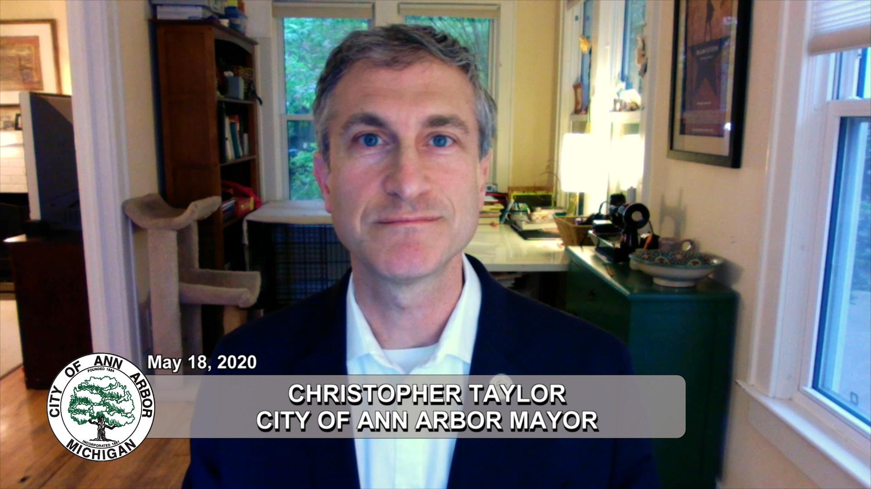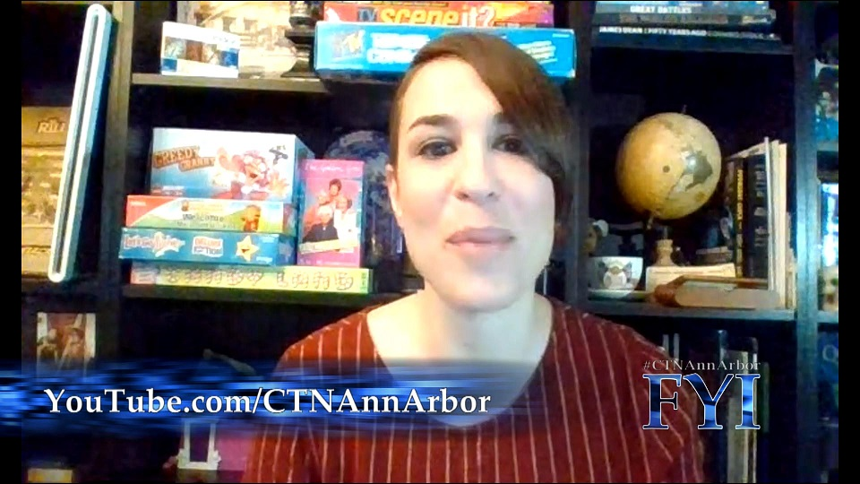

Not so good

