## Veterans Court Partners

## U.S. Government

## Department of Veterans Affairs

Ann Arbor VA Medical Center

**State of Michigan**

15th Judicial District Court

Department of Veterans Affairs

State Court Administrative Office

## Washtenaw County

Board of Commissioners

Department of Community Corrections

and Rehabilitation

Prosecuting Attorney’s Office

Public Defender’s Office

Department of Veterans Affairs

**Washtenaw County Veterans Treatment Court**

**A court-supervised treatment program for defendants who have served in the U.S. Armed Forces**

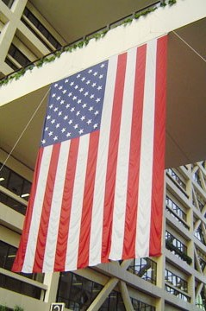

## City of Ann Arbor

## City Council

City Attorney’s Office

Ann Arbor Police Department

## Others

Dawn Farms

Eisenhower Center

University of Michigan

Veteran’s Law Clinic

# Contact Information

Judge Karen Quinlan Valvo 15th Judicial District Court

Paul Graveline

Veterans Court Coordinator

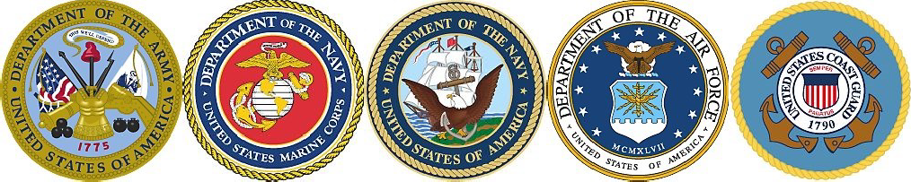Phone: 734-794-6761 x47542

PGraveline@a2gov.org

Rebecca Elder

Probation Officer

Phone: 734-794-6761 x47537

RElderr@a2gov.org

## 15th District Court

## Washtenaw County Justice Center

## 301 E Huron St. Ann Arbor, MI 48107

# What is Veterans Court?

Washtenaw County Veterans Treatment Court is a problem solving court that serves veterans charged with a criminal offense, who are struggling with addiction, serious mental illness and/or co-occurring disorders. It is an 12-24 month coordinated program that promotes sobriety, recovery, and stability. The court relies on cooperation and collaboration with the traditional problem solving court partners, with the addition of the

U.S. Department of Veterans Affairs Health Care, the Veterans Benefits Administration, County Veterans’ Services, and volunteer

veteran mentors. The program couples judicial reviews with intensive probation supervision including input from a multi-disciplinary team of professionals led by the judge.

# Who is Eligible?

Eligibility is evaluated by the Veterans Court Team on a case-by-case basis. General

requirements include:

* Service in the U.S. Armed Forces for a minimum of 180 days with a discharge status of anything other than dishonorable
* Conviction in Michigan for a misdemeanor
* Residence in close proximity to the Court
* Having a diagnosable mental, behavioral, emotional, or substance use disorder

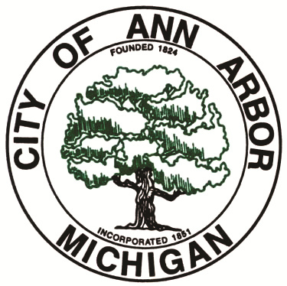

# Entry & Referral Process

1. The case is referred to Veterans Court by the judge, prosecuting attorney, or defense attorney. The court is a universal consent court; all parties must agree to the referral.
2. The Court Coordinator and Probation Agent complete an assessment, which includes interviewing the defendant, signing appropriate information releases, and review of relevant information systems to determine if the defendant is receiving or has in the past received services from the Veteran’s Administration and/or has a prior criminal record.
3. The Probation Agent and Court Coordinator then advise the judge and attorneys whether the defendant meets Veterans Court criteria and makes a recommendation to the Court whether

the defendant should be accepted.

1. An accepted defendant is placed on probation by the judge under the supervision of the Veteran’s Treatment Court. A veteran mentor is also assigned.
2. The defendant then appears for periodic judicial reviews to monitor compliance. For cases not already sentenced, there will be a disposition. The sentence depends on the nature of the case and the performance of the defendant.

# Veterans Court Goals

* Reduce criminal recidivism
* Facilitate participant sobriety
* Increase compliance with treatment and other court ordered conditions
* Improve access to VA benefits and services
* Improve family relationships and social support connections
* Treat and stabilize mental health conditions
* Improve life stability

# Veterans Court Services

* One-on-one judicial reviews
* Ready access to County Veterans’ Service Office and qualifying VA services
* Intensive probation supervision
* Substance abuse, mental health, family and other counseling
* Daily and random drug and alcohol testing
* Medication monitoring
* Employment and housing assistance
* Peer mentoring

# Graduation

Upon completion of the Veterans Court program, participants are given a graduation coin and a certificate of completion. Depend- ing on the sentencing option imposed by the court, some cases are either dismissed or reduced.

# Location

Washtenaw County Veterans Court is held every other Wednesday at 9:30 a.m. in Courtroom 3 of the Washtenaw County Justice Center, 301 E. Huron St., Ann Arbor.