SD Cards for Camcorders
Video: SDHC card Class 6 or Class 10 (4 GB to 32 GB)
Estimated Video Recording Time
Quality | 4GB | 8GB | 16GB | 32GB
HQ (1080i/720p) | 12 minutes | 25 minutes | 50 minutes | 1 hour 40 min
SP (1080i) | 17 minutes | 35 minutes | 1 hour 10 min | 2 hours 20 min
SP (720p) | 22 minutes | 45 minutes | 1 hour 30 minutes | 3 hours
*Note: Actual length of time for videos may vary depending upon subject and camera settings.

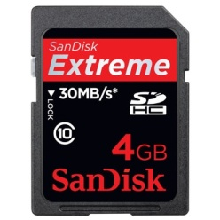
Brands: We recommend purchasing only name brand SDHC cards from Panasonic, Toshiba, SanDisk or Transcend (using cards other than those specified above may prevent data from being recorded correctly or result in loss of data).
SDHC ID
Brand ID
Class ID # - 6 or 10 ONLY
Size ID

Note: DO NOT RECORD files from other devices, including PCs, on the SD cards that you will be using in these camcorders. Files recorded by other devices may reduce the available recording time and/or data may not properly record. Additionally, the remaining space on the card may not be recoverable even after the files are deleted by a PC.
Where to buy: Target, Best Buy, Wal-Mart or shop & compare online. In most cases you will find that the price difference between Class 10 cards and Class 6 is nominal, and we recommend Class10. With a little effort you can find some very good deals.
Prices: Around $10.00 (4 GB) to $89 (32 GB)

