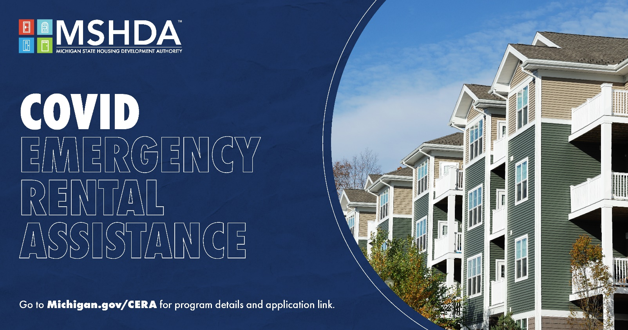

COVID EMERGENCY RENTAL ASSISTANCE (CERA) PROGRAM
ONLINE APPLICATION USER GUIDE

Introduction 3
Eligibility 4
What Assistance is Available? 4
Required Tenant Documents 6
Required Landlord Documents 6
New User Registration 7
Beginning Your Application 9
Basic Information 10
Contact Info & ID 10
Address Info 11
Lease Agreement 13
Utility Company/Internet Provider/Water etc. 14
Household Members 15
Other Assistance 20
Release and Signatures 25
Finalizing your application 26
What Happens Next 26
Check Application Status 26
Cancel vs. Save for Later 26
Getting Back to Your Account 27
What Information Should My Landlord Upload? 27
Landlord Basic Info 28
Landlord Contact Info 29
Tenant Information 29
Lease Document 31
Payment Ledger Information 31
Landlord Information 32
W-9 Upload 32
Release and Signature 33

Introduction
Having trouble paying or receiving rent? MSHDA has federal funds available to help tenants facing pandemic-related hardships avoid eviction while also ensuring landlords can recoup owed rent through the COVID Emergency Rental Assistance (CERA) program.
MSHDA administers CERA through its statewide network of local nonprofit agencies. We encourage everyone who is eligible to apply today and take advantage of a program that can help restore housing stability.
The tenant or landlord can initiate the online application process. The tenant or landlord will need to enter the tenant's name, address and email address, and the landlord's email address. This will initiate emails to both the tenant and landlord for them to complete their portion of the application.
Service agencies will communicate via email with the tenant and landlord if additional information is needed. The tenant and landlord will receive notice via email when the case is processed and how much funding has been approved.
If you need assistance with the application, contact Housing Access for Washtenaw County (HAWC) at 734-961-1999.

Eligibility
You may be eligible for the COVID Emergency Rental Assistance (CERA) program if you meet all the following conditions:
- Have received a past-due rent notice, notice to quit or a court ordered summons, complaint, or judgment for unpaid rent after March 13, 2020
- Have a gross household income below 80% area median income (AMI), for the area
- Have experienced an eligible COVID hardship since March 13, 2020.
- A state ID in the tenant’s name (with supporting proof of residency if the address does not match the unit) 5. A lease agreement in the tenant’s name (if a written lease was completed). Learn more about eligibility at https://www.michigan.gov/cera.

What Assistance is Available?

Rental Assistance
The amount of rental assistance you can get is based on months, not a dollar amount. Your income will determine the number of months of rental assistance you can get.
Tenants whose income is less than or equal to 50% of Area Median Income (AMI) are eligible for 12 months of rental assistance (including up to 3 months future rental assistance). Tenants whose income is 51-80% of AMI are eligible for 10 months of rental assistance (including up to 3 months future rent). As long as a tenant’s income is not more than 80% of AMI, they may be eligible for up to an additional three months of rental assistance for future rent. The amount of future rent assistance depends on funds available.
The rental assistance will pay for 100% of each month’s rent, up to 150% of HUD’s Fair Market Rent Value. Any part of your rent that is over that limit cannot be paid by CERA.
People are not allowed to get CERA funds to cover rent for months they already received other emergency rental assistance. This includes emergency rental help, not long-term help like a section 8 voucher or other housing subsidies. For example, if someone got rental assistance from the previous pandemic assistance program to cover all the rent they owed for November, they cannot get CERA to cover that month. However, if a tenant still owes money on the “tenant portion” from a settlement agreement or conditional dismissal established by another rental assistance program (including EDP in 2020), CERA could cover that month. If a tenant has a Section 8 voucher and has been unable to pay the tenant portion of rent, CERA could assist with the tenant portion in arrears.

Utility Assistance
The amount of utility assistance you can get is based on the number of people in your household. The income requirements for utility assistance is the same as the requirements for rental help. Eligible tenant households will get a single, lump sum payment, even for future utility cost payments. Tenants can apply to HAWC for utility assistance even if they do not need rental assistance.
Utilities that will be covered include all of the following:
- Gas
- Electric
- Wood (and wood pellets)
- Internet
- Water and sewage
Only tenants can get utility assistance — not homeowners. If you are a homeowner facing a utility shut-off, you may qualify for other public assistance programs. Use the MI Bridges portal to apply for assistance from MDHHS.
Renters up to 80% of AMI are available for the following utility assistance:
- Households of 1-2 people can get a maximum of $1,500, $300 of which can be used for future payment.
- Households of 3-4 people can get a maximum of $2,000, $500 of which can be used for future payments.
- Households of 5 or more people can get a maximum of $2,500, $500 of which can be used for future payments.
- Tenants under 50% of AMI can get another $500 beyond what is listed above if it is needed to fully pay past due utility bills.
If CERA cannot cover all your past due utility bills, HAWC can help you apply for State Emergency Relief or other resources.

Internet Assistance
If you need the internet for school, work, medical visits, to access benefits, or for other necessary activities, CERA can help cover some of these costs. You must already have internet service at the time you apply or be able to show that you used to have it, but it was cut off due to nonpayment. If you are eligible, CERA can give you a one-time payment of $300 to help you keep or restore internet access to your household. Where possible, this will be paid to the internet provider and reflected as a credit on your account. In other cases, this will be paid directly to the tenant applicant, who is responsible for paying the internet provider. Tenants will get $300 regardless of what the actual costs of internet access are.

Legal Help
Legal aid lawyers are available in every county to help tenants who are facing eviction. The legal aid provider in Washtenaw County is Legal Services of South Central Michigan. Many times, there will be legal aid lawyers present at court that tenants can speak to before, during, or after their first hearing. Hearings may be in person or virtual. Even if your hearing is virtual, the judge may give you the option to speak with a legal aid lawyer in a “breakout room.”
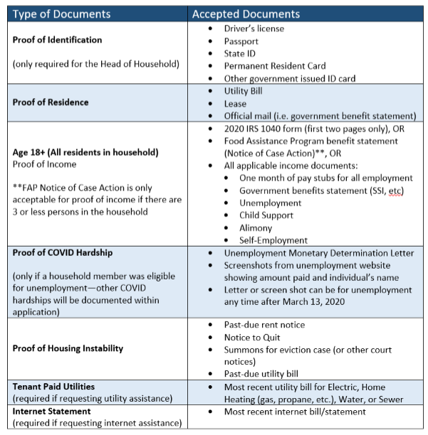
Even if you have already had your first hearing, legal aid lawyers can help at any stage of an eviction case. Use the Eviction Resource page to find the contact information for your local legal aid.

Required Tenant Documents
As you begin your application, you should gather the following documents to include in your application:

Required Landlord Documents
- W-9
- Ledger showing all rent due and payments in 2020 and 2021
- Lease for unit (if a written lease was executed at any point in the past)

New User Registration
- To register, visit https://ceraapp.michigan.gov/.
- Click the apply now button to get started with the registration process. To change your language preference to Spanish, click on “View Dashboard” and return to https://ceraapp.michigan.gov/.
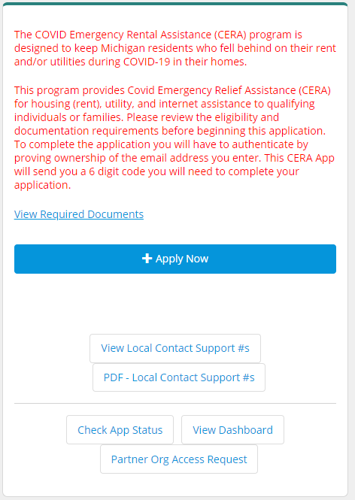

- Fill out the tenant first and last name (your name), tenant email (your email), and landlord/agent email. Click “Next” to continue.
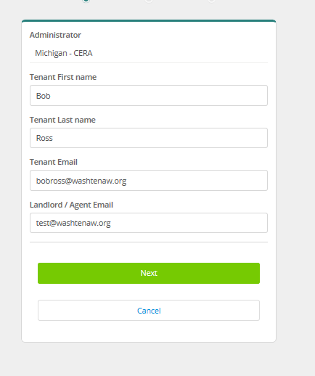

- On the next page, fill in your home address. For example, if your address is 2295 W Stadium Ave., Apt. 12, Grand Rapids, MI 49525, you should complete the page like the following:
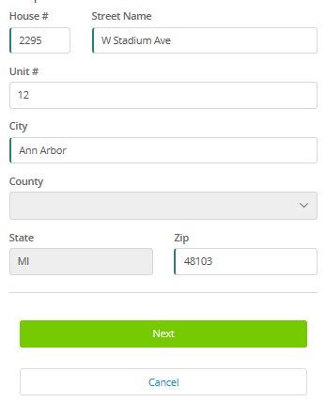
When information is filled out, click “next”.
- On the next page, confirm that your county is correct. Also, confirm that your email and your landlord’s email is correct. Click Authenticate Email/Begin App.
- Check your email for a verification email and when you’re ready to process, click the link at the bottom of the email to begin your application.
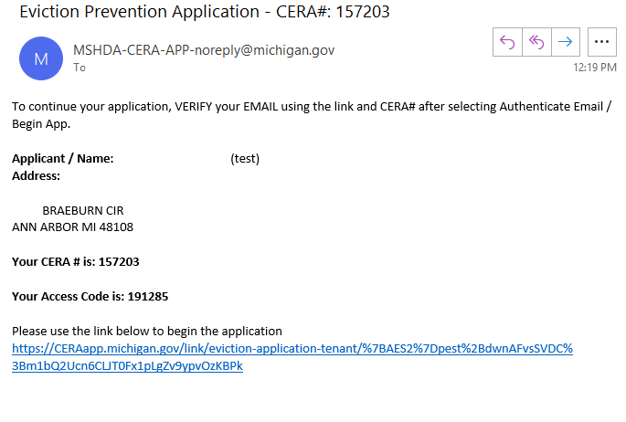

Beginning Your Application
- The link in your verification email will route you to the eviction tenant intake form. Choose your preferred language (i.e. English or Spanish).
- Enter your CERA # (six digit number provided in the verification email) and the six digit access code and click the verify button.
- If you need a new code or did not receive an email with the code, click on the bottom link that reads “click here to get a new email message”
- The next page will autofill your first and last name. Verify this is correct and click “Complete section”.
- The next page that reads “Summary” is the main landing page for all required information. For each section, you will find a green check mark on the left side of the page when all required information is complete for that section
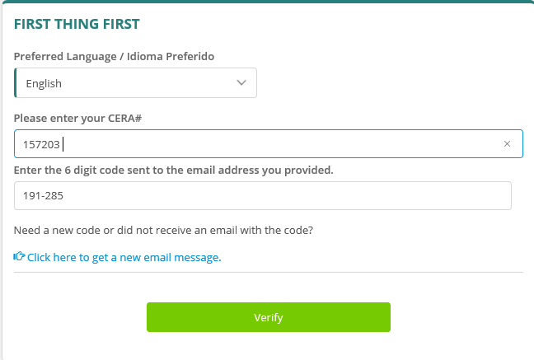

Basic Information
Answer yes or no to the question “Is your unit public housing?”. Answer yes if you live in a subsidized housing unit. If you are unsure, you can contact your landlord or your local housing commission.
Ann Arbor Housing Commission: (734)-794-6721
Michigan State Housing Development Authority: (517) 241-0809
Ypsilanti Housing Commission: (734)-482-4300
Verify your first and last name and click “complete section”.

Contact Info & ID
- Confirm your email address is correct—it should autogenerate from your registration
- Type your home phone number
- Type your cell phone number (if it is the same as your home phone, reenter the same number)
- Upload a copy of your Photo ID – this can be a driver’s license, state ID, passport, permanent resident card, or other government issued ID card.

Your photocopy can be a PDF or an image. See below for step-by-step instructions.

How to Upload a Photo ID
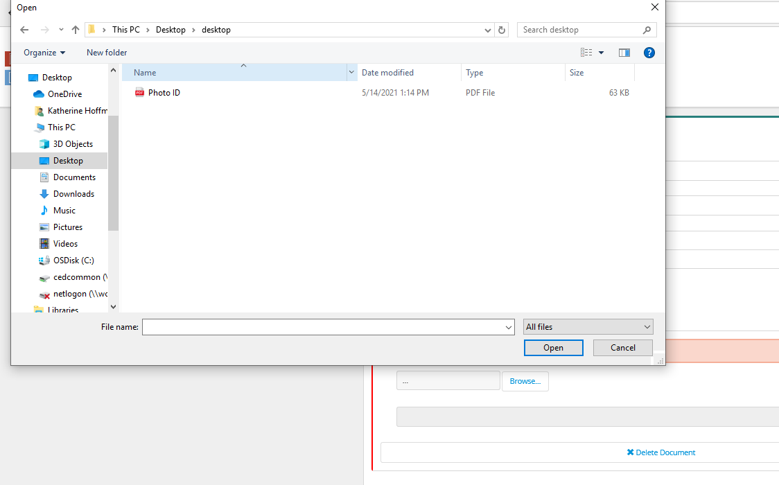
- If you have access to a scanner or a printer with scanning functions, place your preferred photo ID on the scanner and make a copy to your computer/device. Save the copy to your desktop. Alternatively, take a photo on your mobile device or tablet and send it to your email address (via text message or Mail App). Open in your email and save to your desktop. Make sure the file name is something you can easily locate on your computer.
- Navigate to the section of the page that reads, “Upload a Photo ID”.
- Click the “browse” button and when the file window appears, click “desktop”. Locate the file of your Photo ID copy on your computer’s desktop and click “Open”
- If you have multiple documents, click the to upload another document and repeat the steps above.
- When completed, click “Complete Section”

Address Info
Your address information should autogenerate from your registration. Confirm the address is correct and click next.
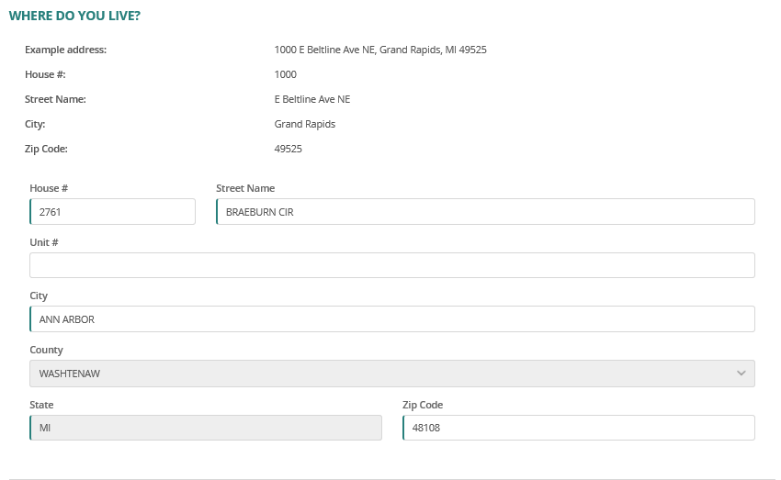
On the next page, answer yes or no to the question, has your landlord filed for eviction?
Fill in the following information about your unit:
- Unit contract rent $: This is the monthly amount of rent currently being paid to your landlord and should match what is reflected in your lease.
- Total rent arrears ($) due to landlord: This is the Total amount of any back rent that your landlord claims that you owe.
- Unit size (number of bedrooms): the size (in bedrooms) of your unit
- Period lease start date: the date your lease began
- Period lease end date: the date your lease ends
When completed, click next.

Lease Agreement

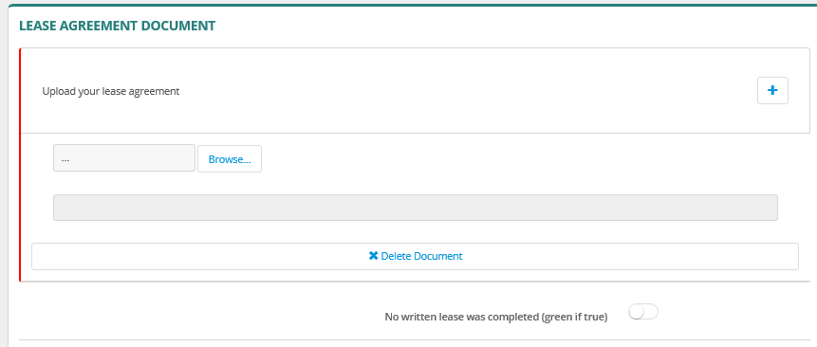
Upload a PDF copy of your lease agreement and click complete section. If no written lease was completed, click on the button to the right of the page (green if true). See below for a step-by-step process for uploading your lease agreement:

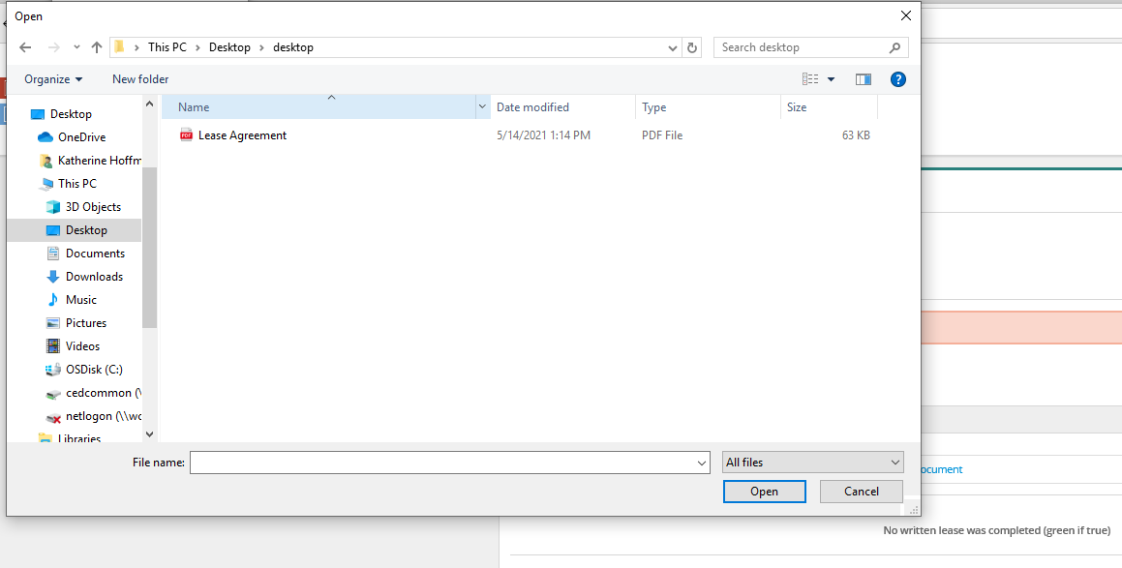
How to Upload a Lease Agreement

- If you have an electronic copy of your lease, ensure that a copy is saved to your computer’s desktop. Or, if you have access to a scanner or a printer with scanning functions, place your lease document on the scanner and make a copy to your computer/device. Save the copy to your desktop. Alternatively, take a photo on your mobile device or tablet and send it to your email address (via text message or Mail App). Open in your email and save to your desktop. Make sure the file name is something you can easily locate on your computer.
- Navigate to the section of the page that reads, “Upload your lease agreement”.
- Click the “browse” button and when the file window appears, click “desktop”. Locate the file of your lease document copy on your computer’s desktop and click “Open”
- If you have multiple documents, click the to upload another document and repeat the steps above.
- When completed, click “Complete Section”.

Utility Company/Internet Provider/Water etc.
- Answer the following questions:
- Are your utilities shut off? Yes or No

- Opt-Out Utility Assistance? Yes or No

- If you answered yes, this means you do not need utility assistance and no other information is required. Click “Complete Section”.
- If you answered no, this means you do need to receive assistance for your utility bills and the following additional information is required:
- Utility Company/Internet Provider/Water etc. (depending on which one you want financial assistance with)
- Account #
  - Example: DTE Energy account number should be a 9 to 12 digit number
- Amount in dollars that is owed to company/provider
- Upload a copy of bill or statement showing the balance on your account

- Upload your most recent utility bills. If you would like help with your home internet bill, upload a recent statement from your internet service provider showing your name, home address and service received. See below for step-by-step instructions on how to upload your utility bills:
Note: CERA can pay for electric, any type of home heating (gas, propane, fuel oil, etc.), water and sewer

How to Upload Utility Bills
- If you have an electronic copy of your utility bills, ensure that a copy is saved to your computer’s desktop. Or, if you have access to a scanner or a printer with scanning functions, place your utility documents, one by one, on the scanner and make a copies to your computer/device. Save the copy to your desktop. Alternatively, take photos on your mobile device or tablet and send it to your email address (via text message or Mail App). Open in your email and save to your desktop. Make sure the file name is something you can easily locate on your computer.
- Click the “browse” button and when the file window appears, click “desktop”. Locate the file of your utility bill copy on your computer’s desktop and click “Open”
- If you have multiple documents, click the to upload another document and repeat the steps above.
- When completed, click “Complete Section”.

Household Members

Basic Info
Your name will default on this page as the head of household. Click on your name and fill out the following:
- Your date of birth (mm/dd/yyyy),
- Answer Yes or No to the question, “Has Social Security # (SNN)?
- If you answer Yes to the above, type your SSN on the next line
- Gender (Indicate if you identify as Male, Female, Non-binary, or Prefer not to answer)
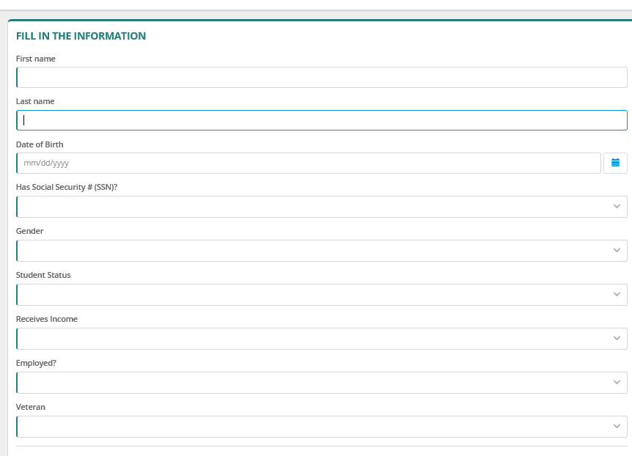
- Student Status (Indicate if you are a Full-Time student, Part Time Student, or not applicable)
- Receives Income– Yes or No
- Employed – Yes or No
- Veteran – Yes or No
- Click Save Changes when complete
- To add additional household members, return to the household member dashboard and click “Add a Household Member” and fill out the following:
- Relationship to Head of Household (i.e. Spouse, Co-Head, Dependent, Other Adult)
- First Name
- Last Name
- The member’s date of birth (mm/dd/yyyy),
- Answer Yes or No to the question, “Has Social Security # (SNN)?
- If you answer Yes to the above, type your SSN on the next line
- Gender (Indicate if you identify as Male, Female, Non-binary, or Prefer not to answer)
- Student Status (Indicate if you are a Full Time student, Part Time Student, or not applicable)
- Receives Income– Yes or No
- Employed – Yes or No
- Veteran – Yes or No
- Complete for all additional household members and click “complete section”

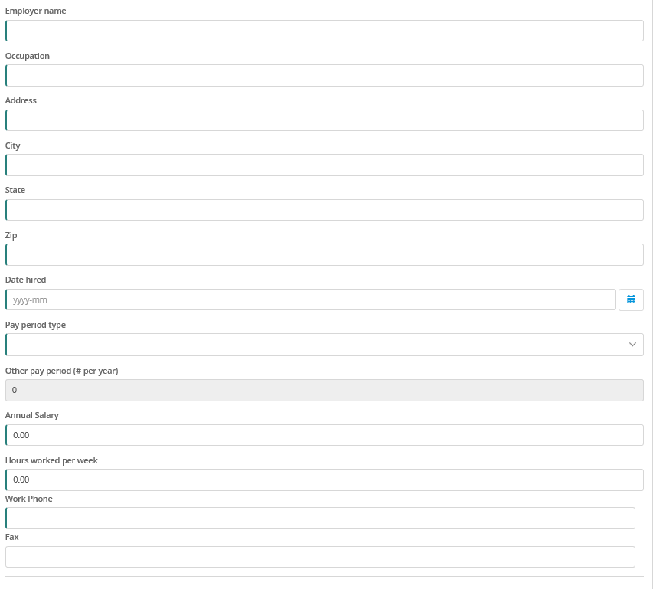
Employment Info (only for household members 18 or older)
Add employer information for each household member (if applicable) including the following:
- Employer Name (Who is your employer?)
- Occupation (What is your job title?)
- Address, City, State, and Zip (Address of Employer)
- Date Hired (What date did you begin working?)
- Pay Period Type
  - Hourly
  - Weekly (paid once per week)
  - Bi-weekly (paid once every two weeks)
  - Twice Month (paid twice per month)
  - Monthly (paid one per month)
  - Annually (paid one per year)
  - Other -Specify under other pay period
- Annual Salary (How much $ do you make in a year?)
- Hours worked per week
- Work phone include your cell phone if you do not have a work phone #
- Fax (optional)
If there are other members of the household (18 years or older) who are employed, make sure to indicate in the dropdown list under name the appropriate member.
Once completed, click “Save Changes”

Annual Income
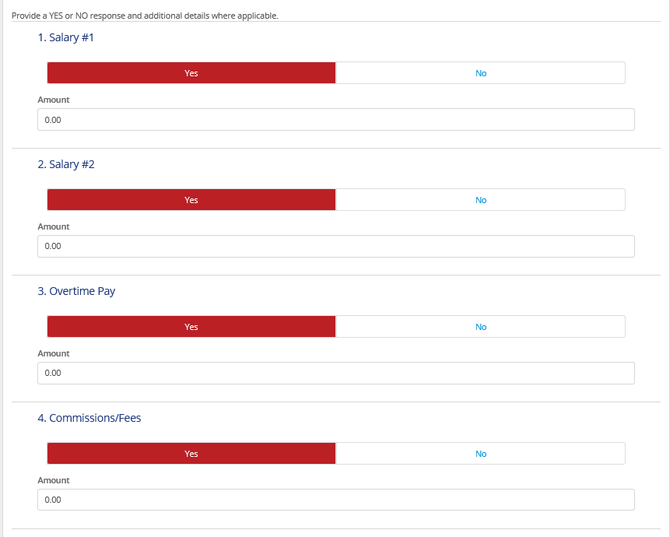
This section includes types of income each member of the households receives and how much $ of each income is received per year. All fields are required, so if you do not receive income under specific categories, answer no. A green check mark should appear next to each category when completed.
Answer each category (#1-19) Yes or No for the appropriate household member. If you do not have income from a specific category, answer no. If you answer yes, indicate the amount of your salary that comes from each source. If the type of income is not listed, use the “Other Income” (#20-21) and indicate the amount.
When completed, click complete section.

Proof of Income (only for household members 18 years of age and older)
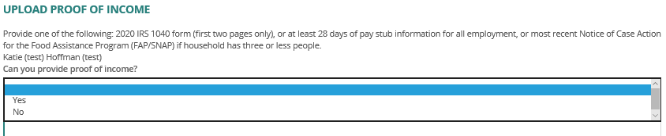
Answer the question, “Can you provide proof of income?” – Yes or No.
If you answered yes (you have proof of income) …
Under the upload proof of income, provide one of the following:
- 2020 IRS 1040 form (first two pages only), or
- At least 28 days of pay stub information for all employment, or
- Most recent Notice of Case Action for the Food Assistance Program (FAP/SNAP) if household has three or less people.
See below for step-by-step instructions on how to upload proof of income.
If you answered no (you do not have proof of income), write an explanation of why you are unable to upload income documents*.
* Below are examples of instances when you might not have proof of income:
- You do not have a phone with a camera to screenshot electronic paystubs and/or do not have immediate access to a computer and printer to print paystubs
  - “I do not have a phone with a camera to screenshot electronic paystubs. I do not have immediate access to a computer and/or printer”
- You are unable to locate paystubs
- Employer will not provide another printed copy of paystubs to applicant therefore self-attestation of this income was accepted
  - “I am unable to locate paystubs at this time and my employer will not provide additional printed copies”
- You have a disability that impedes ability to obtain verification; has a final court date in 10 days for eviction
  - “I have a disability that impedes my ability to obtain verification. I have a final court date in 10 days for eviction”
- You babysit for cash and does not have any form of recordkeeping. Applicant states parents of children are not willing to write a statement of the income provided to applicant therefore self-attestation of this income was accepted.
  - “I receive income from babysitting my neighbor's baby while they are at work. I babysit approximately 10 hours per week, and I am paid $10/hr. I do not have documentation to show that I receive this income and have attempted to get written/signed documentation from my neighbor verifying this as they declined to provide a written statement on 5/24/2021 per our phone conversation.”
If you are a tenant filling out the application and need to write an explanation, include as much information and proof of attempts at obtaining the income documentation as possible in the portal.

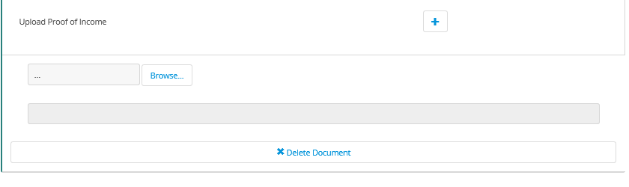
How to Upload Proof of Income

- If you have an electronic copy of your proof of income, ensure that a copy is saved to your computer’s desktop. Or, if you have access to a scanner or a printer with scanning functions, place your utility documents, one by one, on the scanner and make a copies to your computer/device. Save the copy to your desktop. Alternatively, take photos on your mobile device or tablet and send it to your email address (via text message or Mail App). Open in your email and save to your desktop. Make sure the file name is something you can easily locate on your computer.
- Click the “browse” button and when the file window appears, click “desktop”. Locate the file of your pay stub or tax return on your computer’s desktop and click “Open” 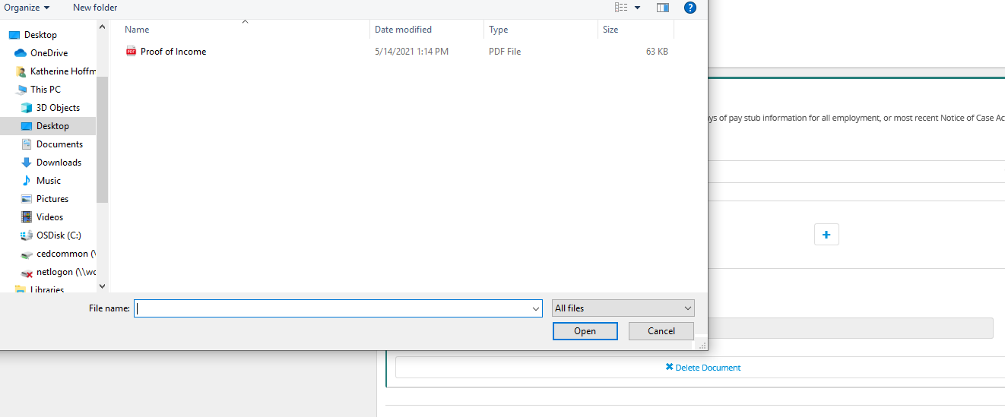
- If you have multiple documents, click the plus sign to upload another document and repeat the steps above.
- When completed, click “Complete Section”.

Demographics
Note: The Michigan State Housing Development Authority (MSHDA) requests this information for reporting requirements. Your responses WILL NOT impact your application status and you will not be discriminated against based on this information.
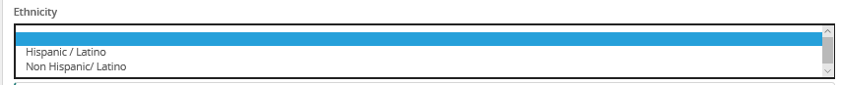
Select your ethnicity from the dropdown menu:
- Hispanic/Latino
- Non Hispanic/Latino
Select your identifying Race from the dropdown menu:
- White
- Black-African American
- Asian
- American India/Alaskan Native
- Native Hawaiian/Pacific Islander
- American Indian/Alaska Native/White
- Asian/White
- Black/African American/White
- American Indian/Alaska Native/Black-African American
- Other/Multi-Race
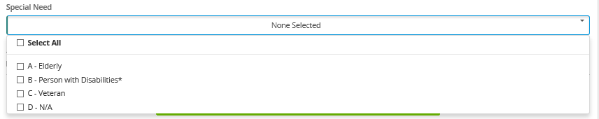
Select any of the following special needs with a check mark:
- Elderly
- Person with Disabilities
- Veteran
- N/A

Other Assistance

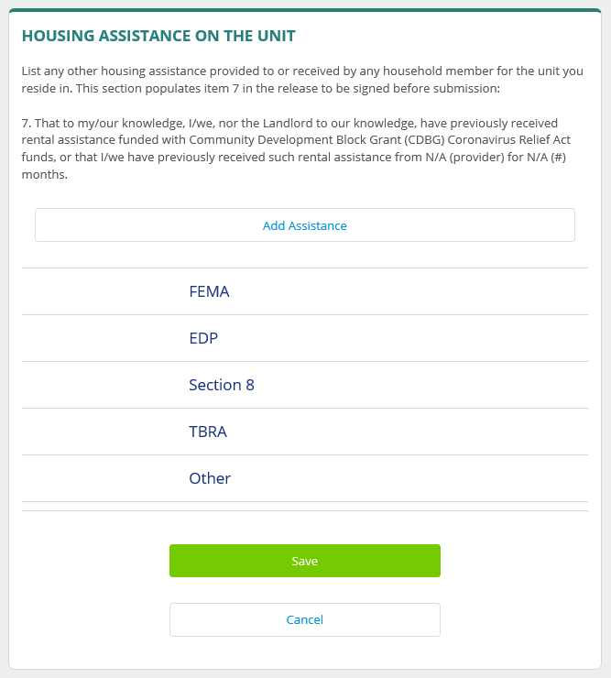
List any other housing assistance provided to or received by any household member for the unit you reside in. This section populates item 7 in the release to be signed before submission:
If you have not received any additional assistance, you must select each assistance program listed and select “No” in the dropdown menu under “Received assistance?”. The system will not allow you to proceed with selecting “No” under each item.
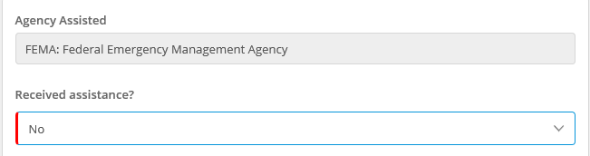
If you have received additional assistance, for each program received, indicate the amount received, date received, and months requested (check mark each month requested). For any programs not listed, click “Add Assistance” and list the project name in the “describe” box. Click save changes.
FEMA
If you have received Federal Emergency Management Agency (FEMA) housing assistance, select “Yes” in the dropdown menu and answer the following:
- If Yes, which disaster? (During what natural disaster or emergency did you receive housing assistance for?)
- Amount (The amount of assistance)
- Date received (the date you received assistance)
- Months requested (the months you asked for assistance) 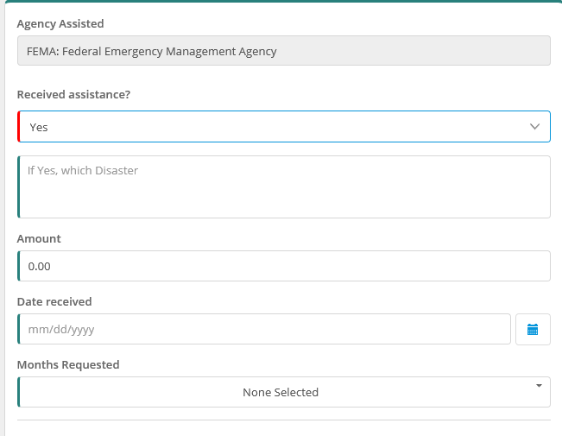

EDP
If you have received Eviction Diversion Program assistance select “Yes” in the dropdown menu and answer the following:
- Amount (The amount of assistance)
- Date received (the date you received assistance)
- Months requested (the months you asked for assistance)

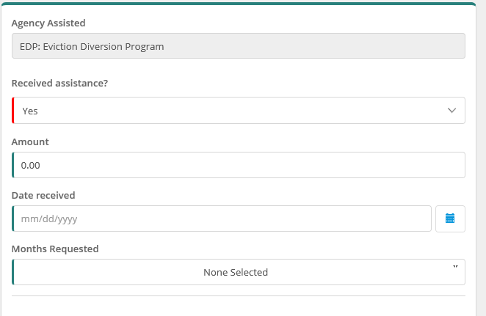

Section 8: Housing and Urban Development
If you have received assistance through Section 8: Housing Choice Vouchers, select “Yes” in the dropdown menu and answer the following:
- Amount (The amount of assistance)
- Date received (the date you received assistance)
- Months requested (the months you asked for assistance)
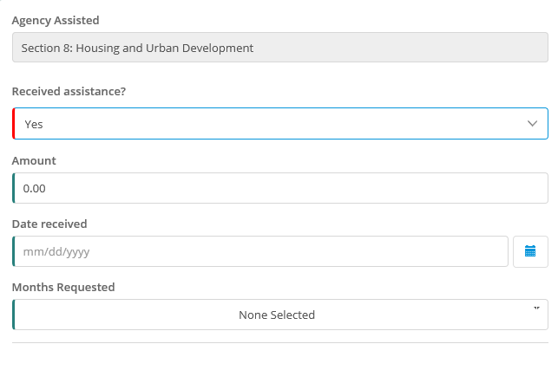

TBRA
If you received Tenant Based Rental Assistance (TBRA), select “Yes” in the dropdown menu and answer the following:
- Amount (The amount of assistance)
- Date received (the date you received assistance)
- Months requested (the months you asked for assistance)

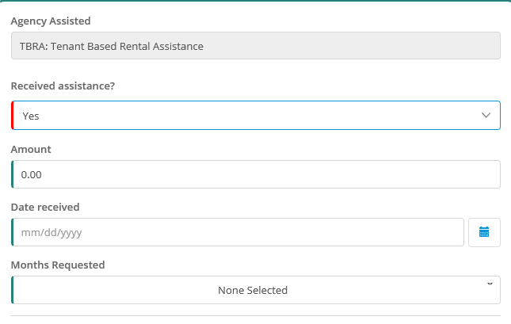

Additional Assistance
If you received any additional assistance that was not listed, click “Other”, select “Yes” in the dropdown menu, and answer the following:
- Describe (What is the program?)
- Amount (The amount of assistance)
- Date received (the date you received assistance)
- Months requested (the months you asked for assistance)
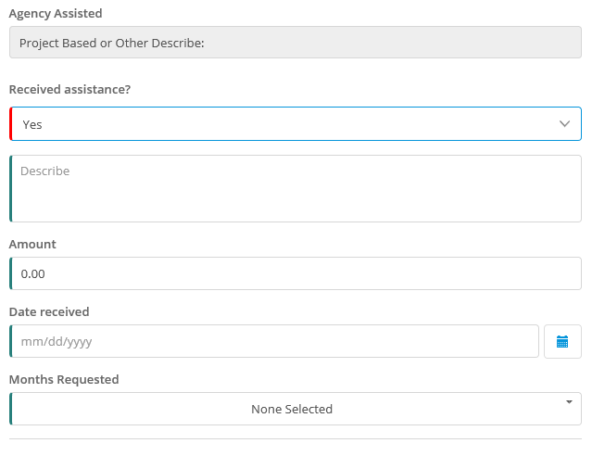

Release and Signatures
Fill in your answers in the release to be signed before submission. The statements are regarding the pandemic’s impact on the household. Any the following statements:
- Has a member of the household qualified for unemployment any time after March 13, 2020? Yes or No
- Household has had a loss of household income due to the COVID-10 pandemic. Yes or No
- Household has had increased household costs due to school closures or medical expenses associated with the COVID-19 pandemic. Yes or No
- Neither of the above apply. Yes or No
- Please describe your financial hardship due to the Coronavirus pandemic including circumstance(s) resulting in loss of income, increased expenses, or other financial hardship.
Upload proof of unemployment*. Click next.
* Proof of Unemployment can include the following:
- Unemployment monetary determination letter
- Screenshots from unemployment website showing payments and person’s name
- Signed letter from applicant stating the time period they received unemployment benefits (only when the other two forms of documentation are unobtainable)
On the next page, add your signature and type your name. Click “Complete Section”.

Finalizing your application
Once you see check marks next to all items on the dashboard, you are ready to submit your application. Click “submit” and a confirmation email should arrive within minutes of submission.

What Happens Next
Once your application for assistance is submitted, it will be received by HAWC and added to the queue of submitted applications. When HAWC reaches your application, it will be assigned to a case reviewer who will review your application to ensure it is complete and to evaluate eligibility.
You may be contacted by email or phone if the case reviewer has any questions about your application. Once review is complete, your application will either be approved or denied. If approved, the case will be sent for processing and payment will be made as soon as possible. In the unfortunate case that your application is denied, you will be notified as to why and provided with information on other resources that may help.

Check Application Status
- Visit https://ceraapp.michigan.gov/p/evictionpreventionappstatus
- Type in your data of birth, last name, and CERA #. See the following for status meaning:
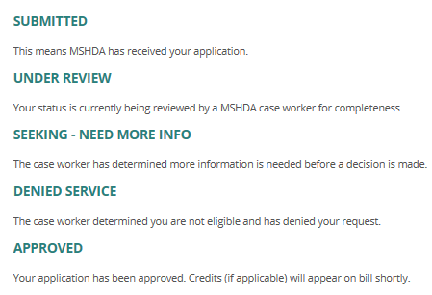

Cancel vs. Save for Later
If you need to exit and complete a section at a later time, please click “save for later” rather than the “cancel” button. Selecting the cancel button may cancel your entire application or cancel out information you have already entered into the system.

Getting Back to Your Account
If you get logged out of your account or if you leave the computer for a period of time and it signs you out automatically, return to your verification email* and click on the link provided at the end of your email. This should return you to the dashboard.
* Subject line: Eviction Prevention Application – CERA #[Account Number])

What Information Should My Landlord Upload?
Your landlord should receive essentially the same verification email that you received with the same CERA code but a different access code.
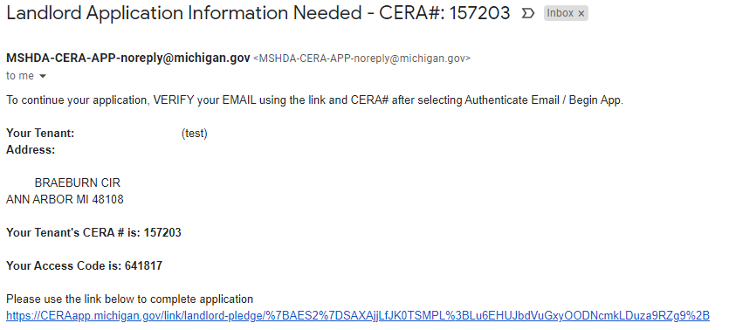
Although you are not responsible for this information, it is good to be aware of a number of documents and information required by your landlord. See below for an idea of what your landlord must submit on your behalf:

Landlord Basic Info
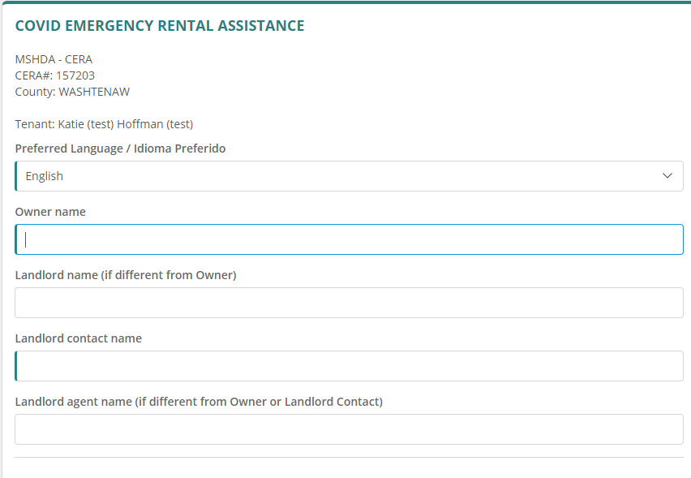
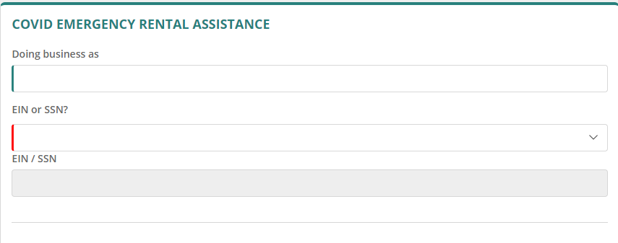

Landlord Contact Info

Tenant Information
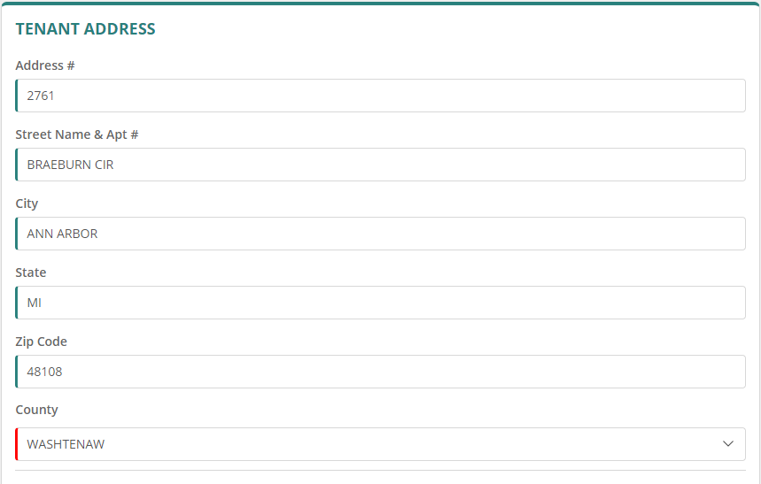
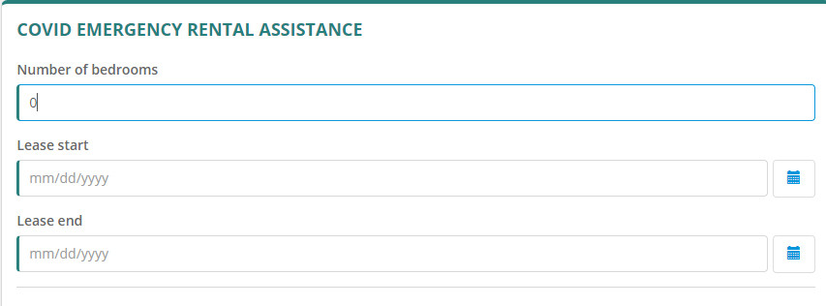
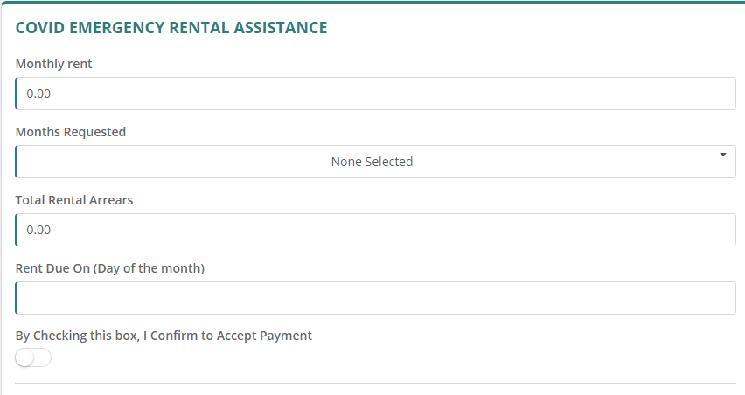

Lease Document
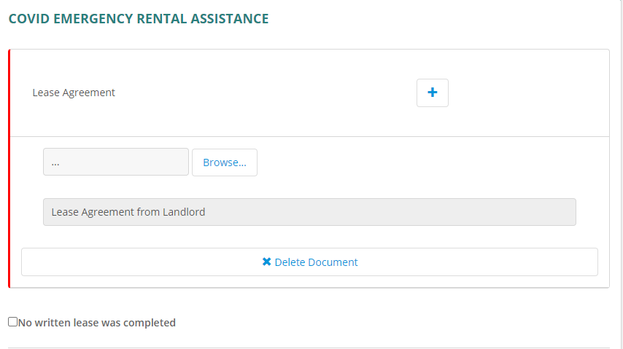

Payment Ledger Information
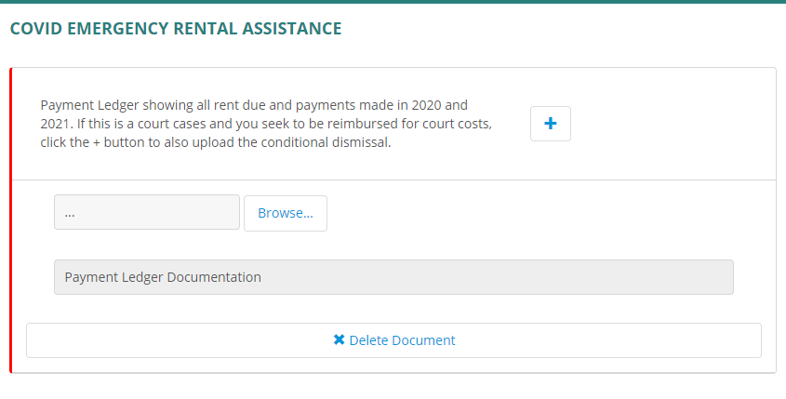

Landlord Information

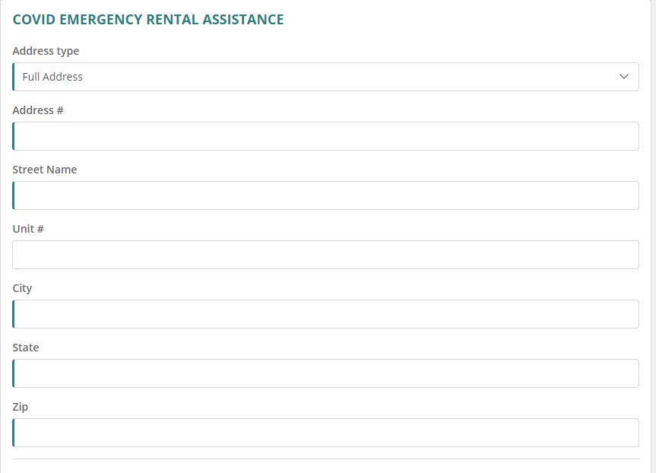

W-9 Upload
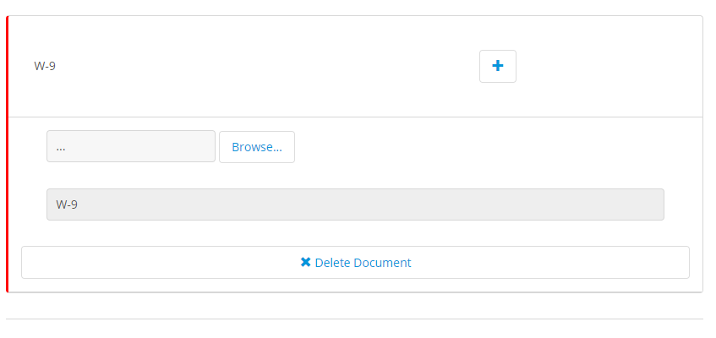

Release and Signature

