Review Application Status
A2JOBS
Click the Sign In button located in the upper right-hand corner of page
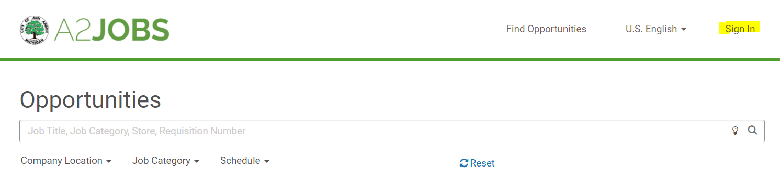
Sign-in with the username and password. If you do not remember the username or password that you applied with, please click the create/reset your passphrase button.
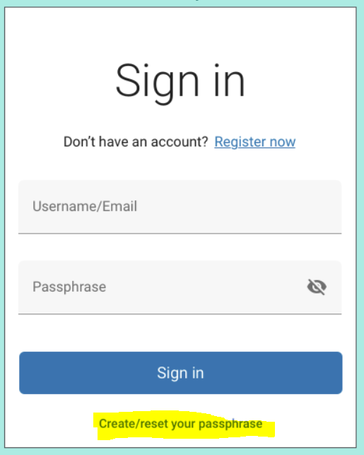
Enter email to receive verification code 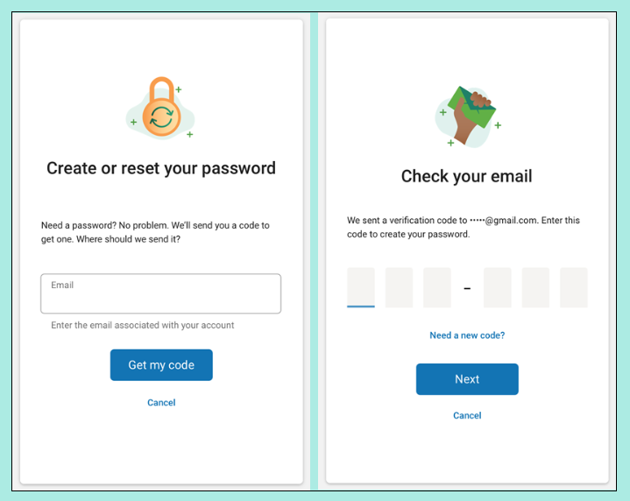

Click on the My Presence button
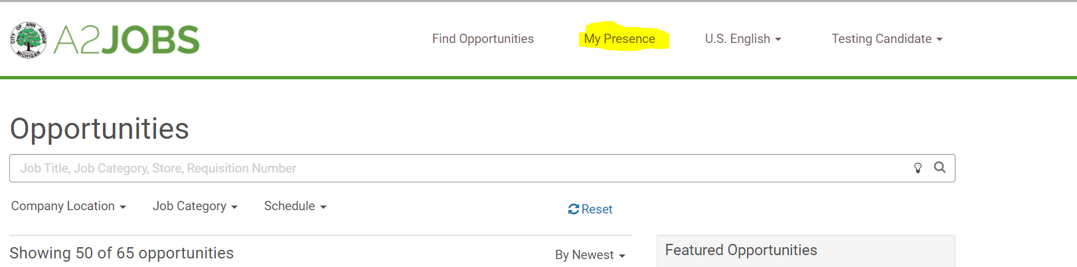

Click on the Applications tab to review the status of your job application(s)
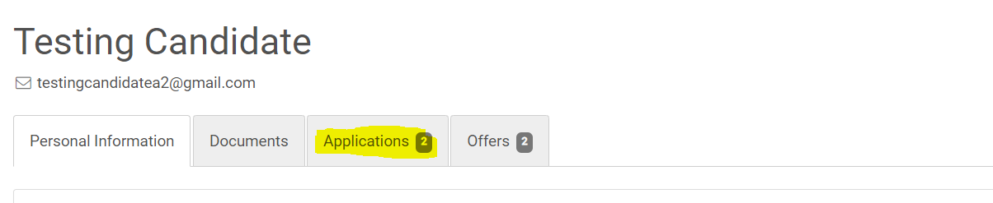

Status for each application is listed in the status column
